The Ongoing Desecration of Djab Wurrung Country
Category: COUNTRY
State/Territory: Victoria (VIC)
Organisation: Djab Wurrung
Topic: Birthing Trees

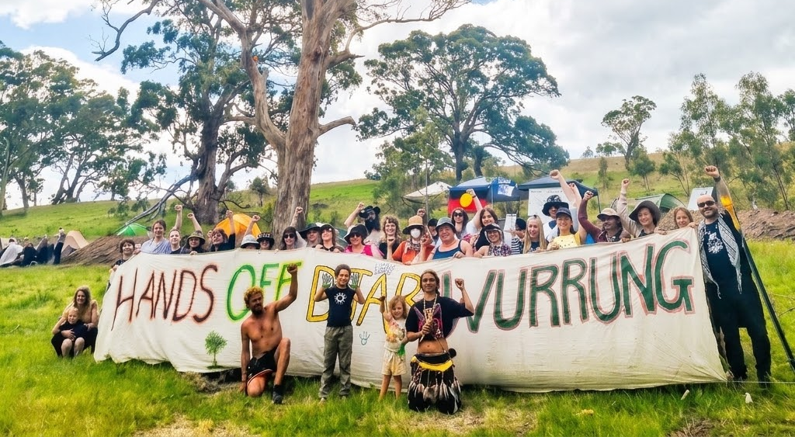

The colonial violence continues, and once again, our sacred sites are the collateral damage of a government that fundamentally refuses to listen. On October 19, 2026, VicRoads and its contractors brutally felled a 400-to-500-year-old sacred birthing tree on Djab Wurrung land, ripping a piece of our Sacred Mother from the earth. We are still dealing with the exact same recklessness and systemic disrespect for Indigenous cultures that has defined this colony since its inception.

This was not just a tree; it was the heart of Naram Naram Tyar—Djab Wurrung women's birthing Country. The precolonial tree bore a significant cultural scar created over two centuries ago, standing as a sacred place where children were born and woven into the fabric of ancient, unbroken songlines. To destroy such a place is an act of profound violence.

The cruelty of the State was on full display. As Djab Wurrung, Gunditjmara, Yuin, and Bidjera woman Yaraan Couzens Bundle detailed, VicPol sent a swarm of riot police to deliberately interrupt a sacred ceremony taking place at the tree's base. To force their agenda, police arrested eight people, explicitly targeting and removing two brave tree sitters who were ripped from the canopy just so heavy machinery could immediately rush in and destroy the site. Authorities forced this through despite knowing a legal defense was being formed to obtain an injunction to protect the land.

The bureaucratic betrayal behind this destruction is as corrupt as it is devastating. While the Eastern Maar Aboriginal Corporation signed off on the Cultural Heritage Management Plan for the highway duplication in March 2026, the Djab Wurrung Women’s Working Group completely rejected it. Men are making decisions and signing away women's sacred sites, and the government is using this flawed Native Title process as a weapon to bypass the matriarchs who are the custodians of Naram Naram Tyar.

We are fed up with the lip service, the empty acknowledgments of Country, and the blatant hypocrisy of the Victorian Government. Our culture is not an obstacle to be bulldozed, and the resistance is far from over.

A frontline camp has been set up on Djab Wurrung Country to actively resist the daily, ongoing destruction of sacred land and trees by contractors. There is an urgent open callout for support, as the movement needs more people on the ground immediately to stand with them. Supporters are asked to come to the camp and bring their friends. Anyone able to assist can email carpooltocountry@proton.me to get the location and an up-to-date list of what to bring.

We must stand with the Djab Wurrung people to disrupt this corrupt process, challenge this destruction on every front, and demand an absolute end to this relentless colonial violence.

